|  |
| --- |
|  |
| 新概念 3 册 |
| Lesson15 Fifty pence worth of trouble |

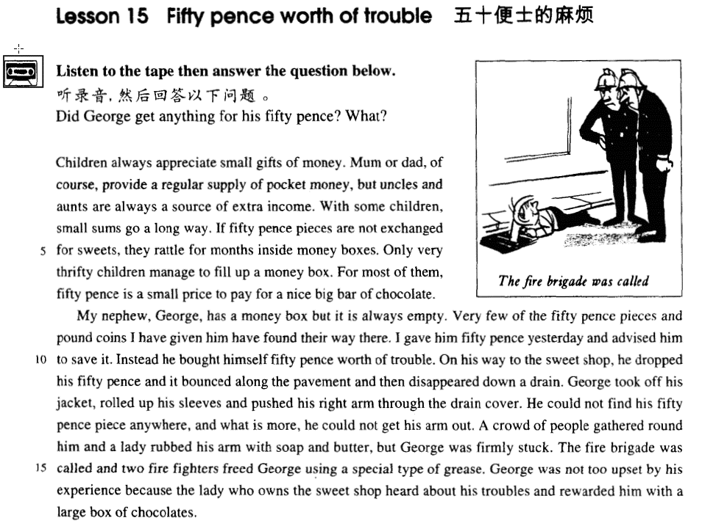

课文

Children always appreciate small gifts of money.

孩子们总是喜欢得到一些零花钱。

Mum or dad, of course, provides a regular supply of pocket money, but uncles and aunts are always a source of extra income.

爸爸妈妈当然经常给孩子零花钱，但是，叔舅婶姨也是孩子们额外收入来源。

With some children, small sums go a long way.

对于有些孩子来说，少量的钱可以花很长一段时间。

If 50 pence pieces are not exchanged for sweets, they rattle for months inside money boxes.

如果50便士不拿来换糖吃，则可以放在储蓄罐里叮当响上好几月。

Only very thrifty children manage to fill up a money box.

但是能把储蓄罐装满的只有屈指可数的几个特别节俭的孩子。

For most of them, 50 pence is a small price to pay for a nice big bar of chocolate.

对大部分孩子来说，用50便士来买一大块好的巧克力，是算不了什么的。

My nephew, George, has a money box but it is always empty.

我的外甥乔治有一个储蓄罐，但总是空空的。

Very few of the 50 pence pieces and pound coins I have given him have found their way there.

我给了不少50便士的硬币，但没有几个存到储蓄罐里。

I gave him 50 pence yesterday and advised him to save it.

昨天，我给了他50便士让存起来，

Instead, he bought himself 50 pence worth of trouble.

却拿这钱给自己买了50便士的麻烦。

On his way to the sweet shop, he dropped his 50 pence and it bounced along the pavement and then disappeared down a drain.

在他去糖果店的路上，50便士掉在地上，在人行道上跳了几下，掉进了阴沟里。

George took off his jacket, rolled up his sleeves and pushed his right arm through the drain cover.

乔治脱掉外套，卷起袖子，将右胳膊伸进了阴沟盖。

He could not find his 50 pence piece anywhere, and what is more, he could not get his arm out.

但他摸了半天也没找到那50便士硬币，他的胳膊反倒退不出来了。

A crowd of people gathered round him and a lady rubbed his arm with soap and butter, but George was firmly stuck.

这时在他周围上了许多人，一位女士在乔治胳膊上抹了肥皂，黄油，但乔治的胳膊仍然卡得紧紧的。

The fire brigade was called and two fire fighters freed George using a special type of grease.

有人打电话叫来消防队，两位消防队员使用了一种特殊的润滑剂才使乔治得以解脱。

George was not too upset by his experience because the lady who owns the sweet shop heard about his troubles and rewarded him with a large box of chocolates.

不过，此事并没使乔治过于伤心，因为糖果店老板娘听说了他遇到的麻烦后，赏给他一大盒巧克力。

词汇讲解

Lesson 15 Fifty pence worth of trouble

**appreciate [ə'pri:ʃɪeɪt]**

**v. 欣赏；感激**appreciate music appreciate wine

I appreciate your help. I appreciate it.

be appreciative of …

I’m most appreciative of your concern for my health. in appreciation of …

I sent him a gift in appreciation of his help. I’m thankful / grateful to you for your help. I’m much obliged to you for your advice.

I’m deeply indebted to you for your encouragement. I owe you (one).

I owe you a lot.

I owe you a big favor. **pocket money ['pɒkɪt 'mʌnɪ]**

n. 零用钱，零花钱

pocket money beer money

pick one’s pocket pickpocket

money burns a hole in one’s pocket

He doesn't have enough money to buy a printer now.

He's not sure how much a printer costs.

He'll buy a computer later this week.

He lost the money he was saving.

W: Have you saved enough to buy that new printer for your computer yet?

M: You know money seems to be burning a hole in my pocket lately. Maybe next month. Q: What does the man mean?

Answer: (A) He doesn't have enough money to buy a printer now.

rattle ['rætl]

**v. & n. 硬物碰撞时当当作响**

The coins rattled in the money box when he shook it. tinkle

I rang the bell and heard it tinkle inside. the tinkle of glass and china

clatter

the clatter of hooves chime

The church bells chimed in the square.

slam / bang

Don’t slam / bang the door.

The door shut with a slam / bang.

thrifty ['θrɪfti] adj. 节俭的

a thrifty housewife

frugal economical

miserly stingy

wasteful extravagant

…, he was so extravagant that he was always in debt. save on ...

economize on ...

save on water / electricity economize on water / electricity **nephew ['nefju:]**

n. 侄子；外甥

nephew niece cousin sibling sibling rivalry

He has two siblings, a brother and a sister. aunt uncle

parental maternal paternal parental / maternal / paternal affection

filial filial duty filial piety

bounce [baʊns]

**v. & n. 弹起，弹跳**

bounce = bound v.& n.

The ball bounced when it hit the ground.

She came bouncing in and told me the good news. That’s the way the ball bounces.

by leaps and bounds: very quickly

Her health is improving by leaps and bounds.

stick [stɪk]

**v. 卡住；粘住；伸出**

The drawer sticks badly.

stick to … cling to … adhere to … I’ll stick to my job until I find a better one.

Stick your tongue.

Stick’em up!

Freeze! Stick’em up! Your money or your life? Definitely my life!

money + worth of + sth.

They had got away with thousands of pounds worth of diamonds. Ross: Well, how was the date?

Rachel: Well I’m alone and I just bought fifteen dollars worth of candy bars, what do you think? I just bought 50 yuan worth of groceries.

Children always appreciate small gifts of money. Mum or dad, of course, provides a regular supply of pocket money, but uncles and aunts are always a source of extra income.

greatly contribute to …

➔ make great contributions to … specially emphasize / stress …

➔ lay / put special emphasis / stress on … fully understand …

➔ have a full understanding of … carefully consider …

➔ give careful consideration to … strongly object to …

➔ have a strong objection to …

造句：这份报告特别强调了必须要吃充足的新鲜蔬菜和水果。

The report specially stresses that it is necessary to eat plenty of fresh fruit and vegetables.

The report lays special stress on the necessity of consuming adequate fresh fruit and vegetables.

source

the source of the Yangtze River

resource

natural resources mineral resources **origin**

the origin of mankind the origin of the universe originate in …

stem from …

have its roots in …

Printing originates in / stems from / has its roots in China.

However, a new type of humour, which stems largely from America, has recently come into fashion.

造句：学习英语对我来说总是一种乐趣。 Learning English is always a source of pleasure for me. with ... / for ... / to ...

For most of them, 50 pence is a small price to pay for a nice big bar of chocolate. The battery can go a long way.

go a long way towards …

The book will go a long way towards solving your problems. come a long way

She traveled a long distance to attend the exhibit.

She likes to paint a variety of things.

She thinks her painting has improved.

She's glad the man saw her students' paintings.

M: I saw some of your paintings at the student art exhibit. They are great. W: Thanks. I feel as though I’ve come a long way.

Q: What does the woman mean?

Answer: (C) She thinks her painting has improved. piece: coin 硬币

Very few of the fifty pence pieces and pound coins I have given him have found their way there.

exchange A for B

Where can I exchange U.S. dollars for British pounds? exchange rate

change A into B

The witch changed the prince into a frog.

piggy-bank

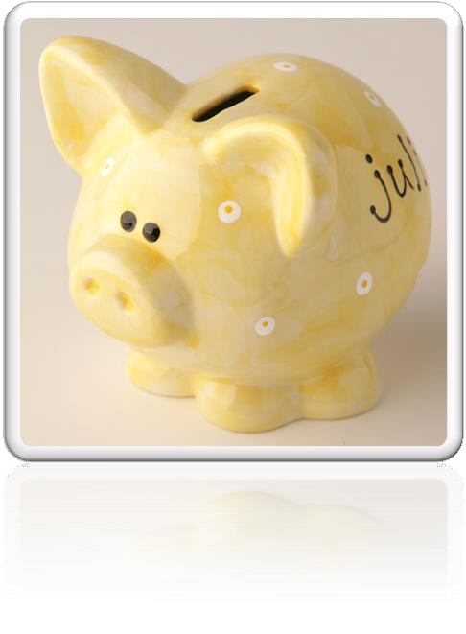

**fill up sth.** 把……装满

Fill her up!

I need a full tank. fill in / out the form

be a small price to pay for sth.

造句: 损失点钱对于提高地位来说算不了什么。

The loss of money is a small price to pay for the rise in status.

be a high price to pay for sth.

造句：为了成功而牺牲健康是不值得的。

The sacrifice of health is a high price to pay for success.

大 形 年 新 颜 国 材 用 + 中心名词

一张新的很沉的黑色的中国式的圆形的大木餐桌

a heavy big round new black Chinese wooden dining table a nice *cup* of tea

a beautiful *stretch* of field

a stagnant *pool* of water

Children always appreciate small gifts of money. Mum or dad, of course, provides a regular supply of pocket money, but uncles and aunts are always a source of extra income. With some children, small sums go a long way. If 50 pence pieces are not exchanged for sweets, they rattle for months inside money boxes. Only very thrifty children manage to fill up a money box. For most of them, 50 pence is a small price to pay for a nice big bar of chocolate.

Very few of the 50 pence pieces and pound coins I have given him have found their way there.

find one’s way

The river finds its way to the sea.

How did my money find its way in your pocket?

They had mysteriously found their way there from the wine cellar!

Specially-made lanterns are hung outside each house to help the dead to find their way.

lose one’s way

I love travelling in the country, but I don't like losing my way.

feel one’s way

The room was dark, so I had to feel my way along the wall to the door.

make one’s way

The hospital had been bombed and Hans had made his way back into Western Germany on foot. Turning back down the main street, we quickened our pace and made our way rapidly towards the stream where we hoped the boatman was waiting.

force / elbow one’s way

He forced / elbowed his way through the crowd.

trace one’s way

We expected the path to end abruptly, but we found that it traced its way through the trees.

edge one’s way

They had to edge their way along this, sometimes wading across shallow streams, or swimming across deep pools.

advise sb. to do advise (that) …

**“should do”型的虚拟语气1.下列动词后的宾语从句中用 (should) do**

order, ask, decide, demand, require, advise, recommend, suggest, insist … He suggested that we (should) help them with English.

The teacher ordered that the homework (should) be finished within half an hour.

Even though the noble was expected to read the letter at each performance, he always insisted that it should be written out in full.

下列名词后的同位语从句中用 (should) do

suggestion, order, request, demand, proposal …

He made a suggestion that we (should) have a fancy dress party. The proposal that John (should) be dismissed is unacceptable.

下列形容词后的主语从句中用(should) do

important, necessary, natural, essential, advisable, strange, surprising …… It’s strange that you (should) say such a thing.

It was important that you (should) tell me all the information. Instead of saving it, he bought himself fifty pence worth of trouble. **instead of doing …,** … 本该……，结果却……

Instead of becoming a doctor, however, he became a successful writer of detective stories. Instead of being five new family members, these children had immediately become a commodity. 造句：本该乘电梯的，我们却走楼梯下去的。

Instead of taking the elevator, we walked down the stairs. 造句：本该学习的，他却浪费时间追女孩子。 Instead of studying, he wastes his time chasing girls.

On his way to the sweet shop, he dropped his 50 pence and it bounced along the pavement and then disappeared down a drain.

on one’s way in one’s way push

**pull drag**

**haul** 薅

George took off his jacket, rolled up his sleeves and pushed his right arm through the drain cover. Acting on a sudden impulse, I collected several dozen, put them in a paper bag, and took them to Robert.

**what is more / what’s more**

What is more, they will not have to rely solely on the written word.

moreover / furthermore besides

**in addition additionally**

**to make things worse to make matters worse**

The team has lost the last two games and, to make matters worse, two of its best players are injured.

gather assemble collect

**mass congregate**

While Alfred's little army slowly began to gather at Athelney, the king himself set out to penetrate the camp of Guthrum, the commander of the Danish invaders.

A large crowd had assembled outside the American embassy. A crowd soon collected at the scene of the accident.

Demonstrators had massed outside the embassy. A crowd quickly congregated around the speaker. **a bar / cake of soap**

a slice of butter

**the fire brigade the fire department fireman firefighter**

… and two fire fighters used a special type of grease to free George.

George was not too upset by his experience because the lady *who owns the sweet shop* heard about his troubles and rewarded him with a large box of chocolates.

hear of / about … know of / about … learn of / about … reward sb. with sth.

造句：观众们对这位表演者报以雷鸣般的掌声。

The audience rewarded the performer with thunderous applause. a reward of ₤1,000

award sb. sth.

She was awarded the Nobel Prize for her work in medical research. the Academy Award

本文体裁：记叙文 (narrative)

文章线索：

题目：新颖有趣，引人注意

第一段：作铺垫：孩子喜欢零花钱→来源（父母/亲属）→少数节俭，多数立刻花掉第二段：叙述事情经过：(when, where, who, why, what, and result)，照应题目。